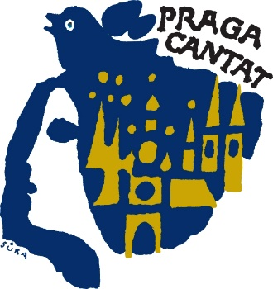Praga Cantat

U Ladronky 508/4

169 00, Praha 4, Czech Republic

Email: brych@pragacantat.com

**www.pragacantat.com**

# Application form

# 35th PRAGA CANTAT 2024

# International Choir Competition and Festival

# Prague, 31. 10. – 3. 11. 2024

If you decide to take part in our festival, please send us the application form by **31. 7. 2024**.

Upon request you will receive the music for the compulsory compositions.

OfficialName of Choir: ..........…………………………………………………………………………...............

Full Address: ..........…………………………………………………………………………..................................

Type of Choir (male, female, mixed choir, youth): .............…………………………………….................

Total No of travelling people : ............................... No of travelling active singers: ……………………

Year of Foundation: …...............................................................................................................................

FullName of Conductor: ……………………………………............………………………...........................

Conductor´s date of birth: ………………………………………………………………………………………

Contact person, phone number, email: ………………............……………………………………………..

………………………………………………………………………………………………………………………….

## Please, mark the category of your choice (max. 3 categories, the jury will decide on participation in the categories after the application deadline).

## A male choirs E choirs with programme of sacred composition

## B female choirs F folksong

**C**  mixed choirs **G** festival (out of competition)

**D** girls, boys, mixed youth choirs **S**Senior choirs aged over 55

aged 12 to 24 years with an average age of the choir over 60 years

**List of songs:**

### Composer (FULL NAME) Title Length Language

1. …..……………………………………………………………………………………...........................................

2. ……………………………………………………………………………………….............................................

3. ………………………………………………………………………………………….........................................

4. ………………………………………………………………………………………….........................................

5. ………………………………………………………………………………………….........................................

Comments of the festival committee on the programme:

…………………………………........................................................................................................................

**We have ordered following hotel category since: ........................... until: .................................**

**(The accomodation includes breakfast)**

##### Category **

##### Category ***

##### Category ****

Approximate No of DBL………………….……..SGL………………………..Multiple……………………….….

**Date of arrival to Prague:**

**Date of departure from Prague:**

**We would like you to provide:**

* **longer stay YES NO from : to: total No.of days:**
* **half-board YES NO full-board YES NO**
* **bus for the stay in Prague YES NO from: to:**

Other requests:

........................................................................................................................................................................

........................................................................................................................................................................

**Date / Signature: …………………………………………………………**